***Chemistry notes:***

***Topic 4 – Chemical Changes:***

**The pH scale and neutralisation:**

The pH scale is a measure of how acidic or alkaline a solution is.

* 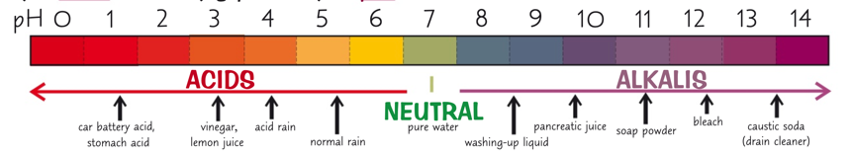What is the pH scale?
  + The pH scale is a measure of how acidic or alkaline a solution is.
  + It goes from 0 – 14
    - The lower the number the more acidic it is (0,6)
    - The higher the number the more alkaline it is (8,14)
    - A neutral solution such as pure water has a pH of 7
* How to measure the pH of a solution?
  + Using an indicator,
    - Indicator is a dye that changes colour depending on whether its above or below a certain pH
      * Universal indicator gives the colours in the diagram above.
  + Using a pH probe
    - A pH probe is attached to a pH meter measures the pH electronically
    - The probe is placed in a solution and the pH is given on a digital display as a numerical value
      * This makes it more accurate than an indicator
* What is an acid?
  + An acid is a substance that forms aqueous solutions with a pH of less than 7
  + Acids form H+ ions in water
* What is a base and alkali?
  + A base is a substance with a pH greater than 7
  + An alkali is a base that dissolves in water to form a solution with a pH greater than 7
  + Alkalis form OH­­­­+ ions in water
* What is neutralisation?
  + Neutralisation is the reaction between acids and bases:
    - acid + base 🡪 salt + water
  + They can also be seen like this:
    - H­+(aq) + OH-(aq)🡪 H2O­(l)
  + When neutralisation occurs, the products are neutral.
    - This can be shown using an indicator

**Strong acids and weak acids:**

* A close up of a logo

  Description automatically generatedWhat is a strong acid?
  + A strong acid is an acid which is completely ionised in aqueous solution
    - Examples include:
      * Hydrochloric, nitric, sulfuric acids
  + The stronger the acid, the lower the pH
* What is a weak acid?
  + A weak acid is an acid which is only partially ionised(dissociate) in aqueous solution
    - Examples include:
      * Ethanoic, citric, carbonic acids
    - The ionisation of a weak acid is a reversible reaction
      * This means there is an equilibrium between undissociated (CH3COOH) and dissociated ions (H+ + CH3COO-)
      * As it is a weak acid, it means that there are less H+ ions which means that equilibrium lies to the left
        + This means that the backward reaction occurs faster than the forward reaction

Which means that there are less dissociated ions

* The pH is a measure of the concentration of Hydrogen Ions
  + For every decrease of 1 on the pH scale,
    - The concentration of H+ ions increases by a factor of 10
      * An acid which has a pH of 4, has 100 times the concentration of H+ ions of an acid that has a pH of 6
  + The equation is:
    - Factor of 10 that the H+ ions increase by = 10-x
      * X is the difference in pH
  + The pH of a strong acid is always less than the pH of a weaker acid if they have the same concentration
* Acid strength VS Acid concentration
  + Acid strength
    - Tells you the proportion of the acid molecules that ionise in water
  + Acid concentration
    - Tells you how much acid there is in a certain volume of water
    - The larger the amount of acid in water, the more concentrated it is
  + An acid can be dilute but strong, or concentrated but weak
  + pH will decrease with increasing acid concentration either way

[**Titration**](Paper%201%20-%20Required%20Practicals.docx)

* Required practical 2

**Reactions of acids:**

* Reactions are neutralisation between an acid and a metal oxide or hydroxide which is a base or alkali
  + All metal oxides and metal hydroxides react with acids to form a salt and water
    - Acid + Metal Oxide 🡪 Salt + Water
    - Acid + Metal Hydroxide 🡪 Salt + Water
* Metal carbonates are also bases
  + They react with acids to produce a salt, water and carbon dioxide
    - Acid + metal carbonate 🡪 Salt + Water + Carbon Dioxide

**The reactivity series:**

* The reactivity series lists metals in order of their reactivity towards other substances
* The higher up the reactivity series a metal is, the more easily they form positive ions
  + Metals
    - When metals react with other substances the metal atoms form positive ions
    - Reactivity of a metal is determined by how easily they lose electrons
    - When metals react with water or acid, they lose electrons and form positive ions
    - So, the higher a metal is in the reactivity series the more easily it reacts with water or acid
* The order of the reactivity series:
  + Potassium
  + Sodium
  + Lithium
  + Calcium
    - VERY REACTIVE
  + Magnesium
  + Carbon
  + Zinc
  + Iron
    - FAIRLY REACTIVE
  + Hydrogen
  + Copper
    - NOT VERY REACTIVE
* How metals react:
  + Some metals react with acids to produce a salt and hydrogen gas
    - Acid + Metal 🡪 Salt + Hydrogen
  + The speed of the reaction is indicated by the rate at which bubbles of hydrogen are given off
    - The more reactive the metal, the faster the reaction will go
      * Very reactive metals react explosively
      * 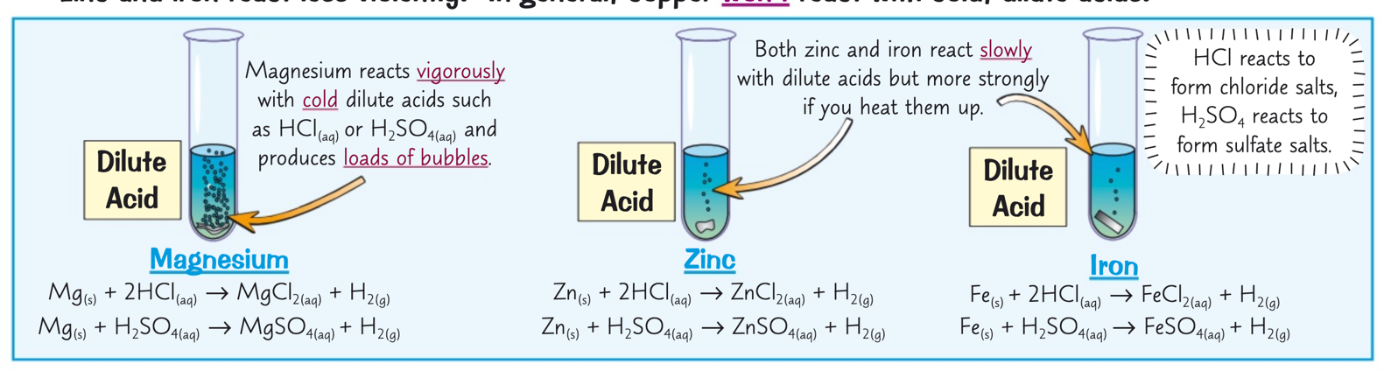Less reactive metals react less violently
* Reactions of metals with water also show the reactivity of metals
  + Metal + water 🡪 Metal Hydroxide + Hydrogen
* Highly reactive metals react with water, but less reactive metals don’t react

**Separating metals from metal oxides:**

* Unreactive metals such as gold are found in the Earth as the metal itself
  + But most metals are found as compounds which require chemical reactions in order to extract the metal
  + Reduction involves the loss of oxygen
  + Oxidation is the gain of oxygen
* Metals less reactive than carbon can be extracted from their oxides by reduction with carbon
  + The ore is reduced as carbon is removed from it
  + Carbon gains oxygen so it is oxidised
    - Iron (III) oxide + carbon 🡪 iron + carbon dioxide
    - 2Fe2O3 + 3C 🡪 4Fe + 3CO2
* Metals higher than carbon in the reactivity series can only be extracted through electrolysis
* Metals below can be extracted through reduction with carbon

**Redox reactions:**

* Oxidation is loss (of electrons)
* Reduction is gain (of electrons)
  + OILRIG
* Reduction and oxidation happen at the same time
* Displacement reactions:
  + Displacement reactions involve one metal kicking another meatal out of a compound
    - A more reactive metal will displace a less reactive metal form its compound
  + If you put a reactive metal into the solution of a dissolved metal compound the reactive metal will replace the less reactive metal in the compound

**Electrolysis:**

Electrolysis is using electricity to split up a melted(molten) or dissolved(aqueous) ionic compound

* Electrolysis
  + There are two electrodes:
    - Cathode Negative
    - A close up of a sign

      Description automatically generatedAnode Positive
  + Positive ions go to the cathode
    - They gain electrons
      * Become reduced
    - Lead ion is positive, so it gains electrons to become uncharged
  + A close up of a sign

    Description automatically generatedNegative ions go to the anodes
    - They lose electrons
      * Become oxidised
    - Bromine ion is negative, so it loses electrons to become uncharged
      * In the equation It shows the lost electron
  + When they become oxidised or reduced
    - The element becomes discharged from the electrolyte
      * This means they’re not part of the flow of electricity anymore
* Extraction of metal from its ore
  + Electrolysis is used if:
    - The metal is too reactive to be extracted by reduction with carbon
    - The metal reacts with carbon
      * It requires large amounts of energy to melt the compounds and produce the electrical current
        + Therefore, it is very expensive and not preferred
  + Aluminium is extracted from the ore bauxite by electrolysis
    - Bauxite contains aluminium oxide
      * Which has a high melting point
        + Therefore, it is mixed with cryolite to lower the melting point

In order to reduce the amount of energy required to melt it

* + - Once molten, it will conduct electricity as the ions are free to move
    - Then the positive aluminium ions go to the cathode where they gain electrons and become reduced
      * Then the aluminium atoms are discharged and sink to the bottom
    - The negative oxygen ions go to the anode where it loses electrons and becomes oxidised
      * The oxygen atoms are discharged and go out of the electrolyte

